Polling Bridge Detailed Design

Description
This is a detailed design document for a pull technology for messages and events originating on our applications outside the Talos network, and bringing the data into Analyst-Console which is inside the Talos network.

Overview
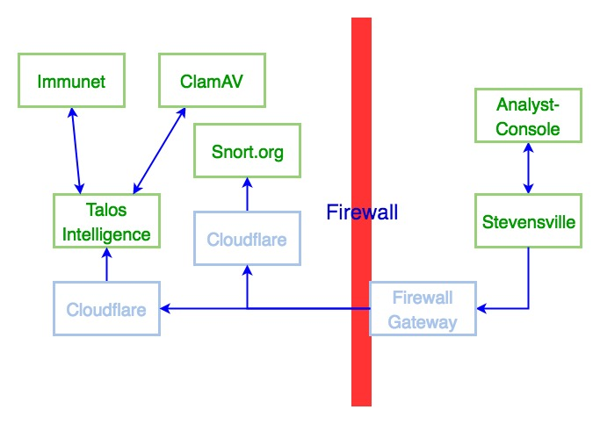
An overview of the whole architecture is provided here. Details specific to the individual components follow this section.
A push architecture was designed and implemented, where messages can be sent to another application, so messages can go from Analyst-Console, to the Stevensville bridge, and from there to Talos Intelligence, or Snort.org. Likewise, in the other direction, the Stevensville bridge can push messages to Analyst-Console. However, because external applications (outside the Talos network) cannot initiate an HTTP request to an internal application (inside the Talos network), the Stevensville bridge will poll Talos Intelligence as a pull architecture.

Push Architecture
There is a peake-bridge-client ruby gem which wraps the Net::HTTP library to make HTTP requests and send a peake-bridge message. An application conforming to the peake-bridge message system, implements a route for channels/:channel/messages to a MessagesController. Since this has been implemented before this polling design, details are brief here.
Analyst-Console and the Stevensville bridge can send messages to each other this way. The bridge or peake-bridge application on the Stevensville host receives messages and schedules them with resque to be forwarded to the next destination. Further, the bridge on Stevensville can send messages this way to Talos-Intelligence.
For this purpose, the Stevensville host does not need an externally addressable IP address. Instead, it has an internal (10.0.0.0 network) address and the NAT feature of the firewall proxies IP traffic using the externally addressable IP address of the firewall gateway.
Further, the DNS for talosintelligence.com is managed by Cloudflare, which proxies IP traffic to the Talos-Intelligence Heroku host. So whether the firewall Gateway and Cloudflare communicate using IPv4 or IPv6 is insulated from the internal hosts communicating with the gateway, and Cloudflare communicating with the Heroku apps.

Polling
Polling will be implemented on the Stevensville bridge application, which will poll Talos Intelligence.
A cron job (or any other scheduling service, such as periodic or at) will call a rake task implemented in the bridge code base. That rake task will make ruby calls into the bridge classes to run a polling job.
The method(s) on those classes will make a web service call to Talos Intelligence to get unread messages, which Talos Intelligence will then consider to be read. The bridge on Stevensville will then take the batch of messages from a polling request, and schedule them in resque to be sent to their destination.
(The firewall gateway and Cloudflare will proxy IP traffic as described for the Push Architecture above, insulating the internal apps and Heroku apps from having externally addressable IP addresses in either IPv4 or IPv6.)

Peake-Bridge-Client
To understand how the polling approach will work, it is useful to understand how much of the design and implementation of the prior approach continues to apply to the new approach.

Peake-Bridge-Client (open HTTP request)
The peake-bridge-client gem is a wrapper around the ruby Net::HTTP calls to open an HTTP request.
The gem provides a class which instantiates a connection object, with parameters used to make the HTTP request. The gem takes parameters such as basic authentication input, https parameters, and Kerberos option. The class knows how to package the options and data into the HTTP request.

Peake-Bridge Message Format
The message format is a JSON encoding of a hash with two keys, “envelope”, and “message”.
The value of the envelope key is a hash with “sender”, “addressee”, and “channel”. The sender is the name of the application originating the message. The addressee is the name of the application that the message is intended for. The channel is the message type, used by the RESTful route and controllers.
The addressee can be used as a key to look up the information of where to send the message. Alternatively, the channel message type could be used to route the message to a list of subscribers. The implementation can use both, or use one and ignore the other value as informational. This is left as an implementation detail not prescribed here.
The message in the top level of the JSON is a free form structure, in a form specific to the channel (message type). Since JSON supports hashes (associative arrays), arrays, strings, and integers, this can be combination of these forms. This will enter Rails or sinatra as `params["message"]`, and the JSON will be parsed, so hashes will be Parameter objects for Rails or sinatra.

Peake-Bridge Routing and Controllers
Messages are sent using RESTful URIs, with a channels collection, the channel name identifying the specific channel resource, a sub-collection messages, and creating a new message from that (sub) collection. (See https://restfulapi.net/resource-naming/)

Push Architecture
The peake-bridge was designed as a purely push architecture. It does a POST http request to send a message, and does not expect a significant response body. (The body can be something silly or "cool".) A 200 response is the only significance that sending the message was successful, and only indicates that the message was received, but not that it was a correct message that successfully processed.

Polling (Pull) Architecture
Since the peake-bridge was designed purely as a push architecture, it has no previous design for returning the results of a polling request, as it would have to do if used for polling.

Analyst-Console
Messages originating in Analyst-Console would be sent to the (internal) bridge on the stevensville server. The analyst-console application would include the peake-bridge-gem which defines the BasicPeakeBridge class. This class can be extended in analyst-console, and the analyst-console code calls the extended classes.
Messages addressed to analyst-console would be sent to a web service API (/bridge/channels/:channel/messages) in analyst-console from the bridge on stevensville.

Peake-Bridge App (Stevensville)

Push
When the bridge on stevensville has a message to send to an Heroku app (as sent from analyst-console), it routes it to Talos Intelligence by calling a web service on the Talos Intelligence.

Poller
The peake-bridge app would implement polling to pull from Talos Intelligence. This would be initiated on a schedule from a UNIX cron job (or some other schedules such as periodic or at). That scheduled job calls a rake task.
The rake task can call ruby code directly. That ruby code would be a method in the peake-bridge app source code.
The ruby method makes an HTTP request and gets a page of (yet) unread messages from Talos Intelligence. The response will indicate if there are remaining messages which were not included in the results. (For instance the number of messages remaining on the queue. If not zero, then there are more messages to read.)
The ruby code loops through these messages and calls the code which receives a message, to put it on a resque queue to be sent to an addressee. That is, the peake-bridge app has a route to receive messages, which calls some code to process it. Likewise the loop through the polled messages will send those messages to be processed.

Firewall Gateway
The firewall gateway is not particularly interesting as we do not implement it and it is generally transparent to us. However, since we had issues with where an IPv4 address might be provided it is interesting to note that the NAT feature in the firewall presents an externally addressable IPv4 address to the world, and proxies IP traffic to internal hosts which have an IP address which is not externally addressable.

Cloudflare
As with the firewall gateway, Cloudflare handles our DNS and is generally transparent and uninteresting. Again, however, this is how Heroku servers (which only support IPv4 not IPv6) are presented with both IPv4 and IPv6 addresses, and proxying IP traffic to the Heroku apps.

Talos Intelligence Messages Module
In order to be polled, there has to be an application which holds a queue of unread (not yet read by the polling) messages. This application may have a web service or internal code to add a message to the queue. It must have a web service to return the unread messages and remove them from the unread status.
Since the Talos Intelligence application is the anchor of the external applications, this queuing functionality can be a module within Talos Intelligence. Best software engineering would be to isolate this functionality to prepare it to be easily moved to another application. This would involve considering the queuing functionality as a module, and the data persistence and object behavior as an API. Here the "module" might just be the "controller" which handles the web service, and the "API' might just be the active record models with methods.
The messaging here (in Talos Intelligence) must be bi-directional. Messages from the bridge are handled with the push architecture as normal. Effectively, this would be an external bridge, which is actually outside the Talos network. Messages bound for the bridge, (and likely Analyst-Console) would be queued and read from the polling.

Outbound Push Architecture
Consider outbound traffic to be from an application inside the Talos Network (Analyst-Console) to an application outside the Talos Network (Talos Intelligence). Here, Talos Intelligence would work in the normal push architecture for peake-bridge messages. It would have a MessagesController, and route for POST to Channels/:channel/Messages. Talos Intelligence would process these messages as normal, directly processing messages sent to it.

Inbound Polling Architecture
Consider inbound traffic to be from an application outside the Talos Network (Talos Intelligence) to an application inside the Talos Network (Analyst-Console). This can be traffic originating in Talos Intelligence, or another external app sending a message to Talos Intelligence to forward on its behalf. (If it is common for traffic to originate in applications other than Talos Intelligence, we can consider moving the queuing module to become its own application. The exception is that Snort.org may file false positives as an interim solution until all false positives are filed through Talos Intelligence.)
Here Talos Intelligence will queue the message onto a queue of unread (not yet read from the polling) messages. This is simply a database of unread messages.
Talos Intelligence will implement an API to return a collection of unread messages, and remove them from the queue of unread messages.

Appendix A Zero Bridge
One approach is to have no bridge at all, but have a communication module inside analyst-console.
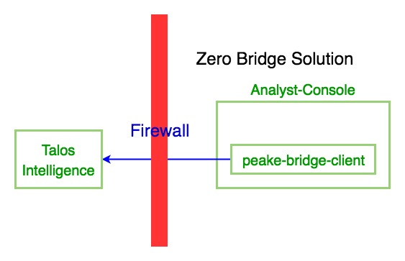

Module of Analyst-Console
In addition to the peake-bridge-client gem, analyst-console would have a module for calling the Heroku station application, and for polling the station for unread messages.

Poller
A cron job would call a rake task in the analyst-console code to trigger the polling.

Appendix B Heroku Station
One alternative approach is to implement an independent application to handle the message queue, instead of using Talos Intelligence.
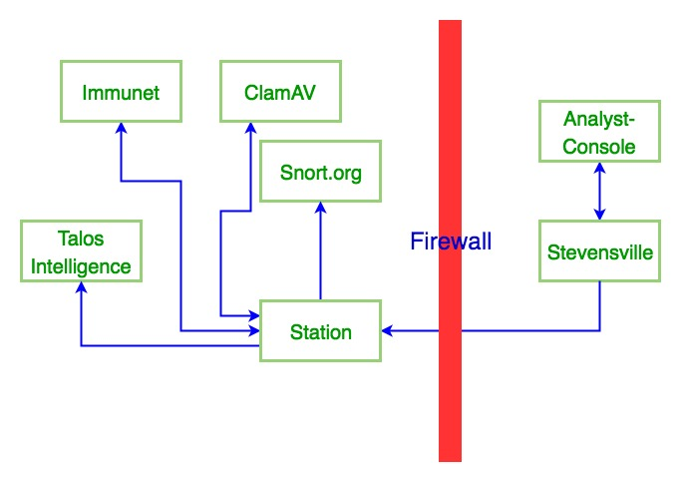
This station application would receive inbound messages and queue them. It would supply a web service to read messages from the queue. When that web service is called it would return a page of those messages and remove the messages from the unread messages queue.
It would also route outbound messages to the appropriate application following the normal push architecture.

